10.1071/IS12034_AC
©CSIRO 2012
Supplementary Material: Invertebrate Systematics, 2012, 26(5,6), 526–538

SUPPLEMENTARY MATERIAL

Suppl. Fig. 1. Bayesian inference (Ronquist and Huelsenbeck 2003) for the 18S analysis was calculated under a GTR model, Γ rate variation and four Γ categories, four MCM chains, a chain length of 20 000 000 generations, a chain temperature of 0.2, subsampling frequency of 4000 generations and burn-in of 100 000 generations. There was little intrataxon diversity in the 18S sequences from the Sør Rondane Mountains so a single representative was used within the Hypsibioidea (JX296322, representing JX296262–76, 294 from cdh40, and JX296286, 293, 304, 310, 313, 318–20, 322, 325, 330–31, 333 from cdh38) and within the Macrobiotioidea (JX296290, representing JX296277–85 from cdh39, JX296287–92, 295–303, 305–309, 311–12, 314–17, 321, 323–4, 326–29, 332 from cdh38, and JX296335–38 from cdh63).
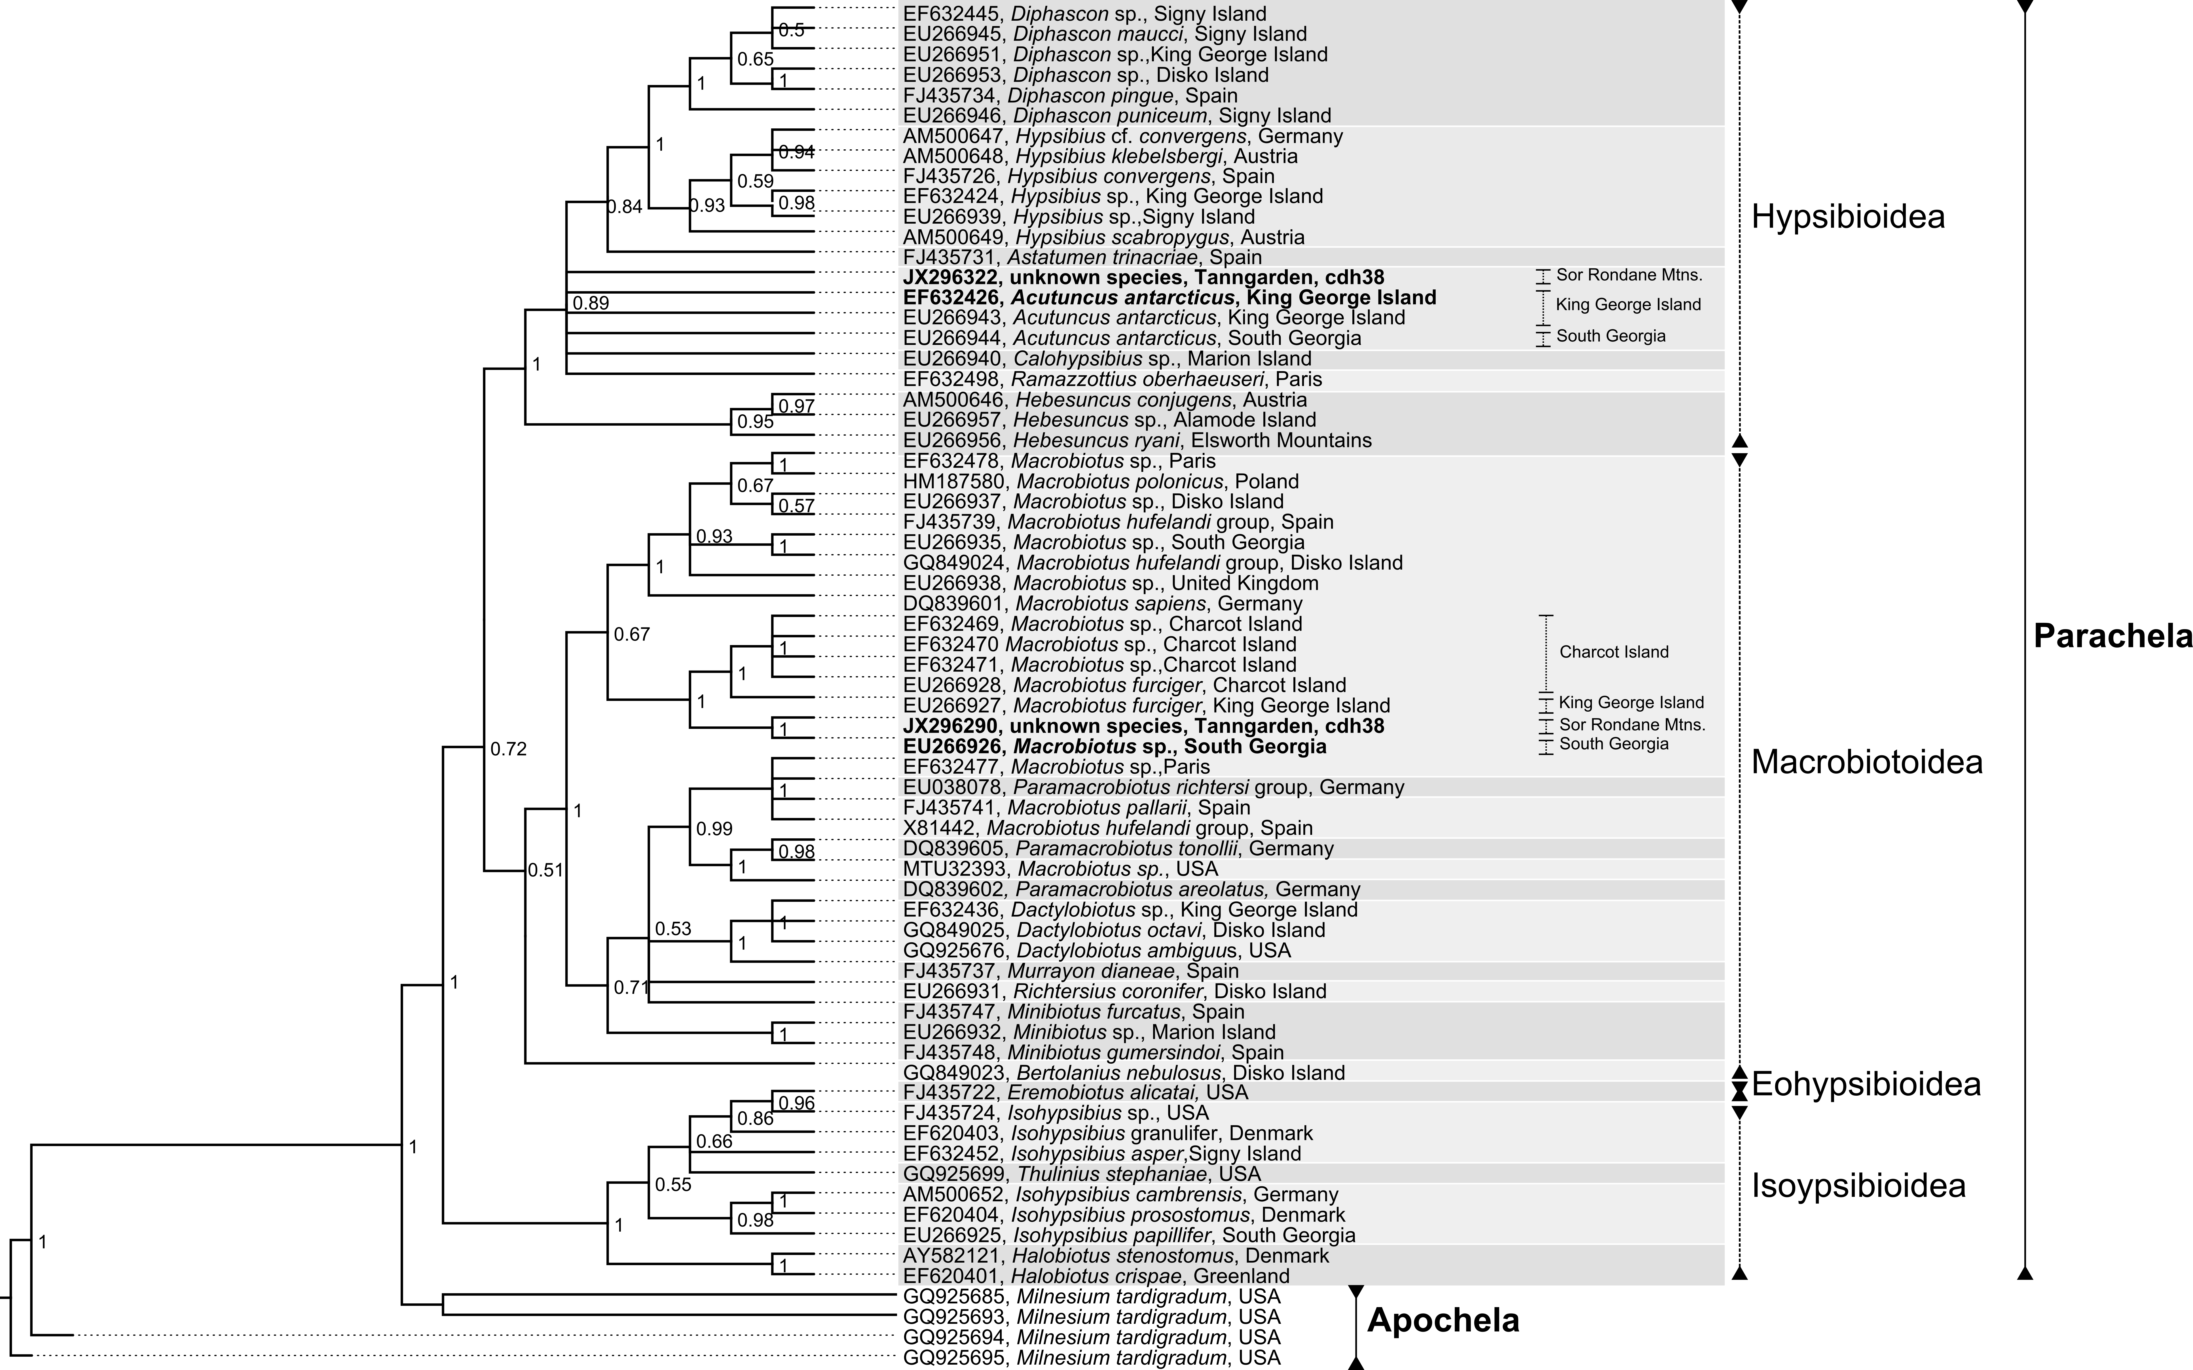

Suppl. Fig. 2. Bayesian inference (Ronquist and Huelsenbeck 2003) for the wingless (Wg) gene was calculated with a fixed JTT rate matrix, four MCM chains of 5 000 000 generations, Γ rate variation, subsampling frequency of 1000 and burn in length of 500 000 generations. All accessions starting with ‘JX’ are derived from this study.

Suppl. Fig. 3. Bayesian inference (Ronquist and Huelsenbeck 2003) for the Macrobiotioidea-related alignment of COI sequences used a GTR+Γ model, four MCM chains, a chain length of 20 000 000 generations, a chain temperature of 0.2, subsampling frequency of 4000 generations and burn-in of 100 000 generations. All accessions starting with ‘JX’ are derived from this study.

Suppl. Fig. 4. Bayesian inference (Ronquist and Huelsenbeck 2003) for the Hypsibioidea-related alignment of COI sequences used a GTR+Γ model, four MCM chains, a chain length of 20 000 000 generations, a chain temperature of 0.2, subsampling frequency of 4000 generations and burn-in of 100 000 generations. All accesions starting with ‘JX’ are derived from this study.


